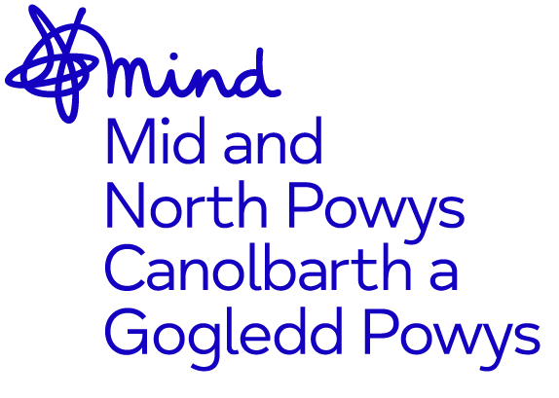
Application for Employment

Please write in black ink.

Section A:

Applications for appointment of (please state job title)

Personal Details (IN BLOCK LETTERS)
SURNAME: FIRST NAME:

ADDRESS:

TELEPHONE:
Home: Mobile: Work(inc Ext):

Email:

EDUCATION AND TRAINING
Please give details of your educational qualifications and training, including subjects taken and short courses where appropriate. You may be required to provide proof of qualifications and training.

QUALIFICATIONS and TRAINING

EDUCATION

CURRENT AND PREVIOUS EMPLOYMENT
(Please include paid, unpaid work and please also explain any gaps in employment)

Present or most recent employer/organisation
Name and Address | Job Title and brief details of responsibilities | From | To

Previous employers/organisations

POST FOR WHICH APPLICATION IS MADE:

Please tell us how you meet each of the criteria listed on the person specification for this post. You can include information from both inside and outside paid work as transferable skills are taken into consideration. The information you provide will be the basis for short listing.

Experience and Qualifications.

Knowledge

Essential Qualities

Continuation page

Please continue on separate sheet(s) if necessary.

Please remember to sign your form as indicated.
I confirm that to the best of my knowledge all information I have given in my application is correct and can be treated as part of any subsequent contract of employment. Any false, deliberate omission or misleading information may be sufficient cause for rejection, or if employed by Mid & North Powys Mind to be dismissed. I agree Mid & North Powys Mind can approach any of my previous employers for a reference to confirm that any information given in relation to my application is correct. I give my consent to using my personal data for personnel, management and monitoring purposes.

Signature Date

If unable to sign we will take submission of this form via email as your consent to the above statement.
SECTION B:
This section will be detached and will not be seen by the selection panel. It will only be used where the selection panel has decided to make an offer of employment.

REFEREES
Please give the names and addresses of two referees, who should not be related to you and one of whom should be your present or most recent employer or supervisor (where applicable). Referees will not be taken up until an offer of employment has been made.
(a) Employer/Supervisor | (b)

CRIMINAL CONVICTIONS
As part of its equal opportunities policy Mid & North Powys Mind wishes to ensure that it does not discriminate against ex-offenders. However, we recognise that some of our posts, for example those concerned with handling sums of money, involve matters where an ex- offender might be in a potentially vulnerable position unless consideration of the person’s background has been made. For this reason, we ask you to complete the following section:

Have you ever been convicted of a criminal offence:- YES NO
If your answer is Yes, please give details of date(s) of offence(s), nature of offence(s) and sentence(s) passed:

NB: Offences that would be deemed as spent under the Rehabilitation of Offenders Act 1974 need not be declared.

Equality and Diversity Monitoring Form

Mid & North Powys Mind wants to meet the aims and commitments set out in its
Equality Policy. This includes not discriminating under the Equality Act 2010, and building an accurate picture of the make-up of the workforce in encouraging equality and diversity.

The organisation needs your help and co-operation to enable it to do this, but filling in this form is voluntary. The information provided will be kept confidential and will be used for monitoring purposes. If you have any questions about the form contact: admin@mnpmind.org.uk or 01597 824411

Please return the completed form with your application.

Gender Identity
Man/boy | □ | Woman/girl | □
Non-binary/agender | □ | Transgender | □
Prefer not to say | □
If you prefer to use your own gender identity, please write in:

Age
16-29 | □ | 30-39 | □ | 40-49 | □ | 50-59 | □ | 60-69 | □ | 70-79+ | □
Prefer not to say □

What is your ethnicity?
Ethnic origin is not about nationality, place of birth or citizenship. It is about the group to which you perceive you belong. Please tick the appropriate box
Asian or Asian British
Indian | □ | Pakistani | □
Bangladeshi | □ | Chinese | □
Prefer not to say | □ |  | □
Any other Asian background, please write in:
Black, African, Caribbean or Black British
African | □ | Caribbean | □
Prefer not to say | □ |  | □
Any other Black, African or Caribbean background, please write in:
Mixed or Multiple ethnic groups
White and Black Caribbean | □ | White and Black African | □
White and Asian | □ | Prefer not to say | □
Any other Mixed or Multiple ethnic background, please write in:
White
English | □ | Welsh | □
Scottish | □ | Northern Irish | □
Irish | □ | British | □
Gypsy or Irish Traveller | □ | Prefer not to say | □
Any other White background, please write in:
Other ethnic group
Arab | □ | Prefer not to say | □
Any other ethnic group, please write in:

Do you consider yourself to have a disability or health condition?
Yes | □ | No | □ | Prefer not to say | □

What is the effect or impact of your disability or health condition on your work?
Please write in here:
The information in this form is for monitoring purposes only. If you believe you need a ‘reasonable adjustment’, then please discuss this with your manager, or the manager running the recruitment process if you are a job applicant.

What is your sexual orientation?
Heterosexual | □ | Gay | □
Lesbian | □ | Bisexual | □
Asexual | □ | Pansexual | □
Undecided | □ | Prefer not to say | □
If you prefer to use your own gender identity, please write in:

What is your religion or belief?
No religion or belief | □ | Buddhist | □
Christian | □ | Hindu | □
Jewish | □ | Muslim | □
Sikh | □ | Prefer not to say | □
If other religion or belief, please write in:

Do you have caring responsibilities? If yes, please tick all that apply
None | □ | Primary carer of a child/children (under 18) | □
Primary carer of disabled child/children | □ | Primary carer of older person | □
Secondary carer (another person carries out the main caring role) | □ | Prefer not to say | □

Are you pregnant or have had a baby on the last 2 weeks?
Yes | □ | No | □ | Prefer not to say | □

Are you married or in a civil partnership?
Yes | □ | No | □ | Prefer not to say | □

Are you a Welsh speaker? Please tick all that apply
I know some words but cannot speak fluently | □ | I can speak fluently | □
I can write fluently | □ | No | □
Prefer not to say | □

